Cover Page
Student Name: Godius Kirwa
Registration Number: BBIT/2024/73552
Course: Bachelor of Business and Information Technology
Unit Code: BIT3208
Unit Name: Advanced Web Design and Development
Lecturer Name: Michael Nyoro
Semester/Academic Year: Year 3 sem 2
Project Details
Project Title: SokoniHub
Selected Technologies: Xampp, Vscode and php
GitHub Link
GitHub Repository Link: https://github.com/Kirwagodi/sokonihub

Table of Contents
Contents
Cover Page 1
Table of Contents 2
1. Project Overview 4
2. Project Folder Structure 4
Week 1: Local Environment Setup 5
1.1 Installation and Testing of Local Development Environment 5
Fig 1.1: Installation of XAMPP 5
Fig 1.2: Apache and MySQL Running 5
Fig 1.3: Localhost Test Page 5
Fig 1.5: Database Connection Test 5
Week 1.2 Reflection 6
Week 2: Wireframes and GUI Design 7
2.1User Interface Planning and System Design 7
Fig 2.1.1: Hand-drawn Wireframe homepage 7
Fig 2.1.2: Dashboard Layout Design 7
Fig 2.1.3: Mobile View Mockup 8
Fig 2.1.5: GUI Prototype 8
2.2 Week 2 Reflection 8
Week 3: JavaScript and PHP Basics 9
3.1 Frontend Interaction and Backend Foundations 9
Fig 3.1.1: JavaScript Form Validation 9
Fig 3.1.2: Password Strength Checker 9
Fig 3.1.3: PHP Syntax Practice 10
Fig 3.1.4: Database Connection Script 10
Fig 3.1.5: Dynamic User Input Handling 10
3.2 Week 3 Reflection 11
Week 4 Database creation 12
Fig 4.1: Database Created in phpMyAdmin 12
Fig 4.2: Users Table Structure 12
Fig 4.3: Products Table Structure 13
Fig 4.4: Database Relationships 13
Fig 4.5: Sample Records in Database 14
4.2 Week 4 Reflection 14
Week 5: User Registration and Login Module 15
Fig5.1: Registration Form 15
Fig 5.2: Login Form 15
Fig 5.3: User Data Stored in Database 16
Fig 5.5: Password Hashing. 16
5.2 Week5 Reflection 17

Project Overview
Sokoni Hub is a full-stack e-commerce web application developed as the BIT3208 semester project. Reflecting a Kenyan-first online marketplace where customers can browse products, create accounts, manage carts, and place orders.

The system covers all topics introduced in Weeks 1 to week 5 of the course: server-side programming, form processing, session management, database design, and CRUD operations.

Project Folder Structure
The project follows the professional folder structure introduced in Week 4:

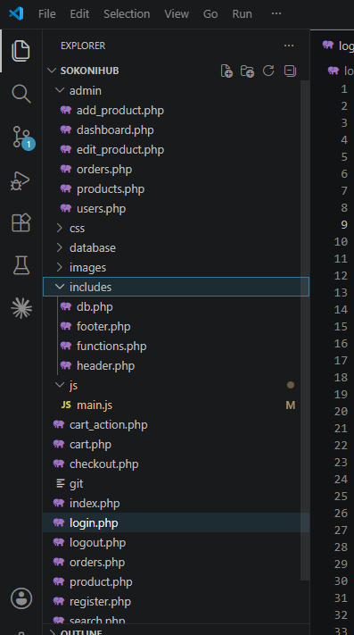

Week 1: Local Environment Setup

1.1 Installation and Testing of Local Development Environment

Fig 1.1: Installation of XAMPP
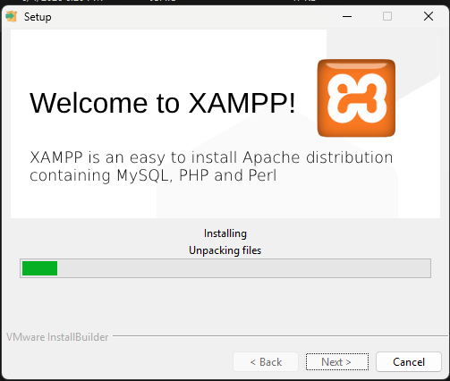

Fig 1.2: Apache and MySQL Running
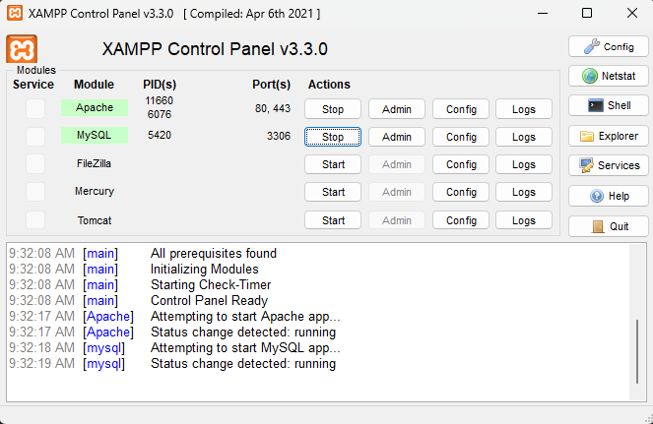

Fig 1.3: Localhost Test Page
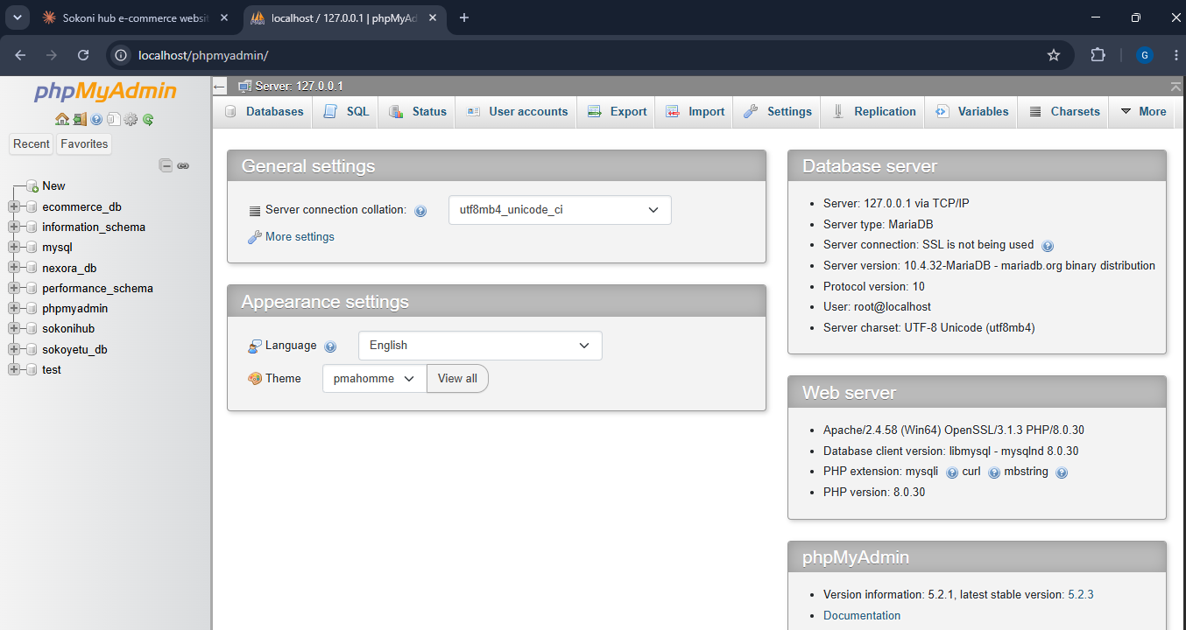

Fig 1.5: Database Connection Test
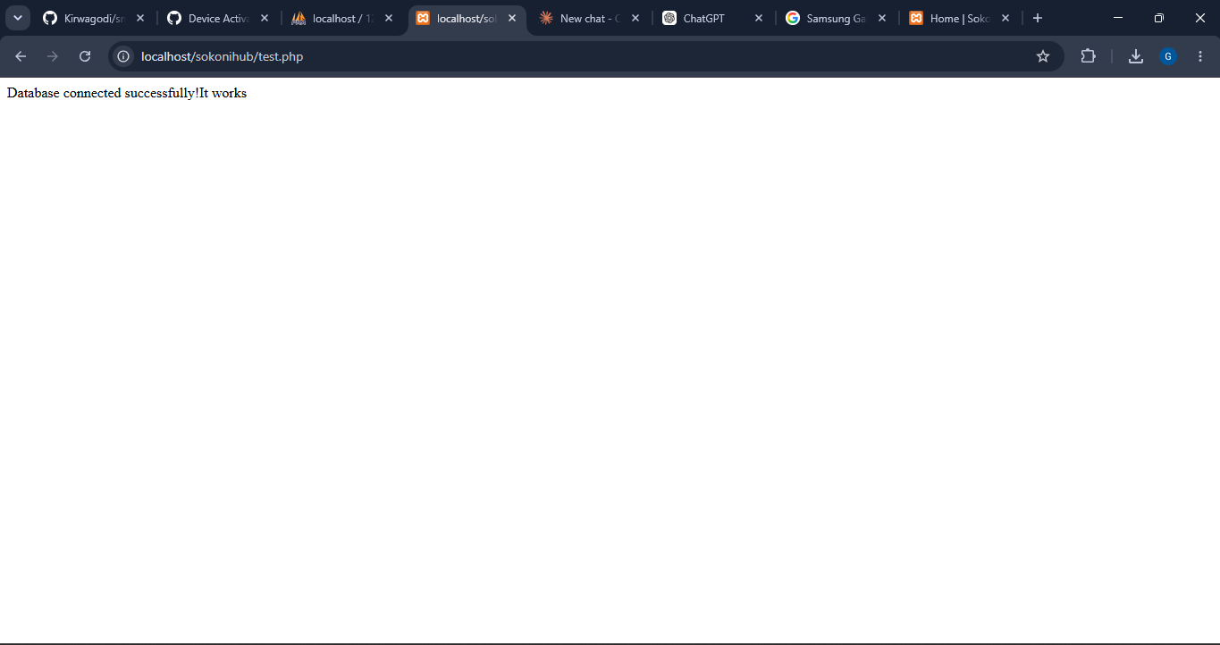

Week 1.2 Reflection
This week focused on setting up the local development environment required for the Sokonihub project:
- I installed XAMPP and configured Apache and MySQL services successfully.
- VS Code was used as the primary code editor for writing and testing PHP scripts.
- One challenge encountered was configuring the database connection correctly, which was resolved by verifying the database credentials and service status.
- The screenshots demonstrate successful installation of XAMPP, execution of localhost pages, creation of a test PHP file, and establishment of a connection between PHP and MySQL.
This setup provided the foundation for system development.

Week 2: Wireframes and GUI Design

2.1User Interface Planning and System Design

Fig 2.1.1: Hand-drawn Wireframe homepage
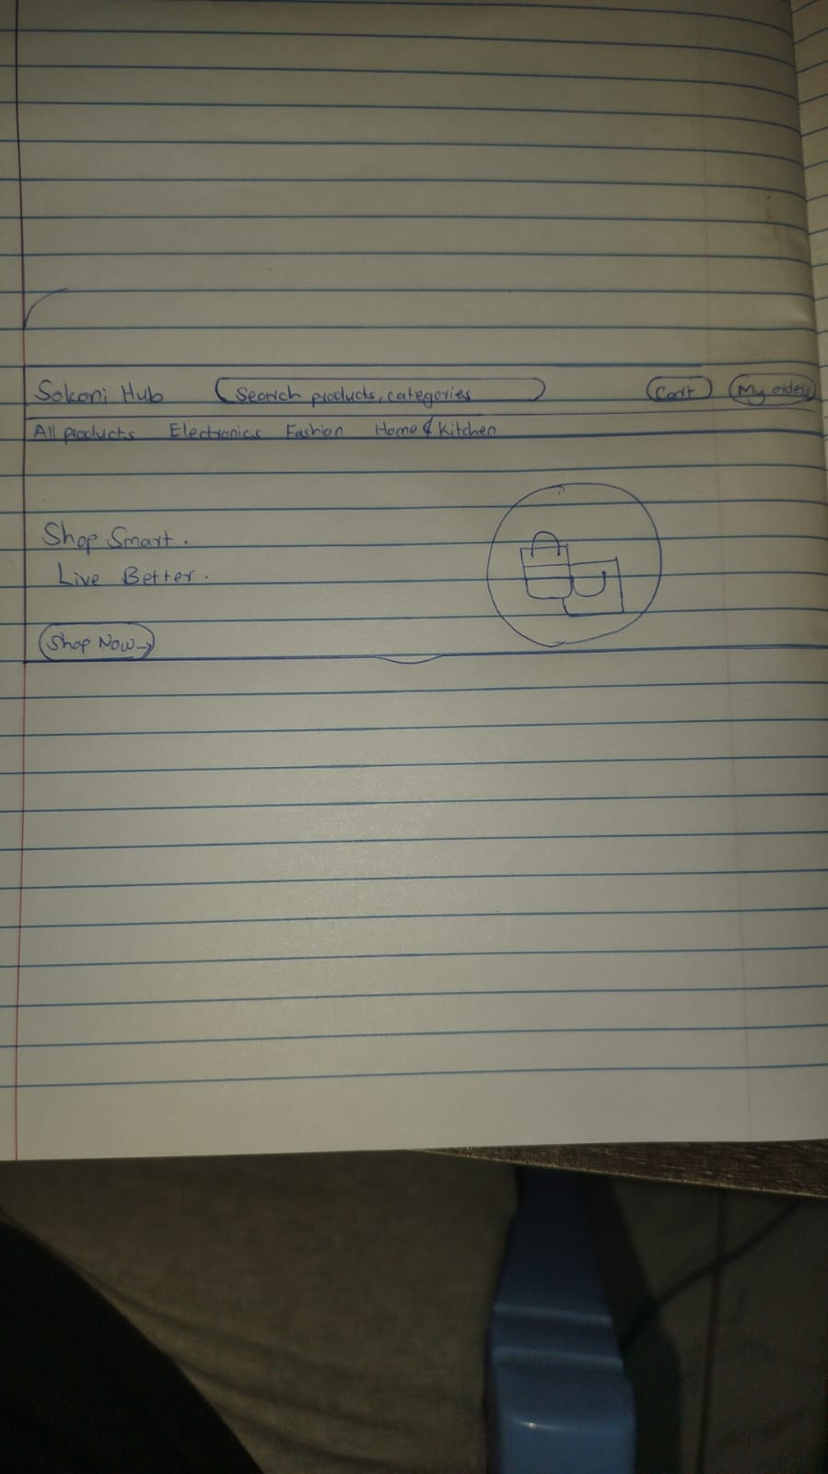

Fig 2.1.2: Dashboard Layout Design
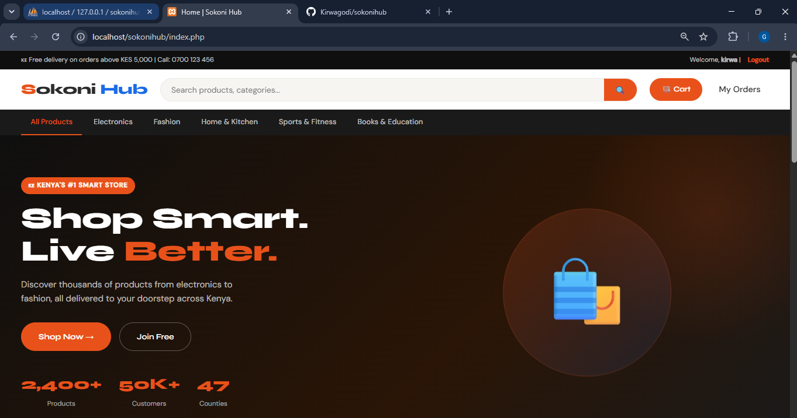

Fig 2.1.3: Mobile View Mockup
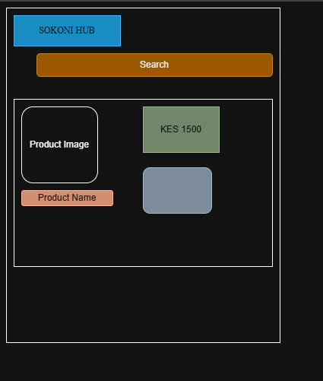

Fig 2.1.5: GUI Prototype

2.2 Week 2 Reflection
During this week, I planned the user interface and overall navigation structure for SokoniHub. Wireframes were created to visualize how users would interact with the system, including login, product browsing, shopping cart, and dashboard pages.
The design focused on simplicity, accessibility, and easy navigation. A mobile-responsive layout was also considered to support users accessing the platform through smartphones. The screenshots demonstrate the design process, navigation planning, dashboard structure, color selection, and prototype development.
This planning stage helped establish a clear development roadmap before implementation began.

Week 3: JavaScript and PHP Basics

3.1 Frontend Interaction and Backend Foundations

Fig 3.1.1: JavaScript Form Validation
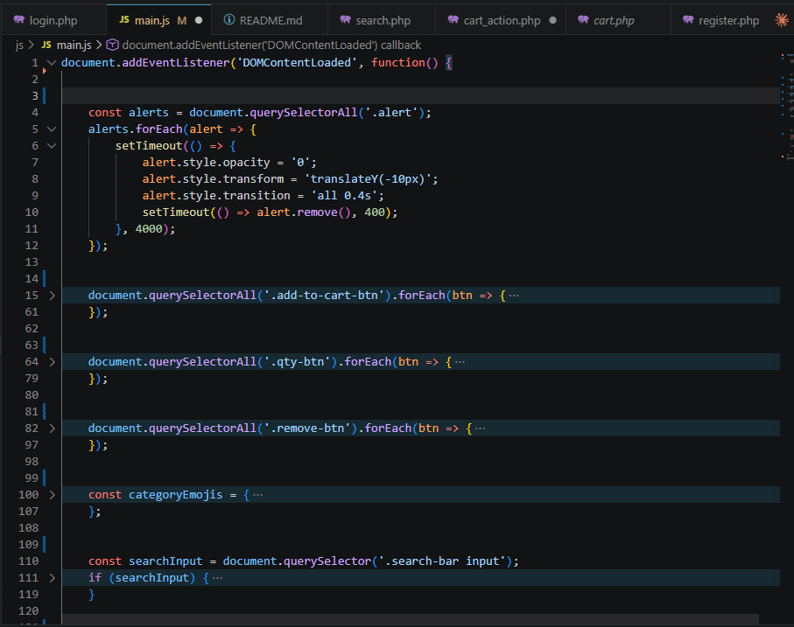

Fig 3.1.2: Password Strength Checker
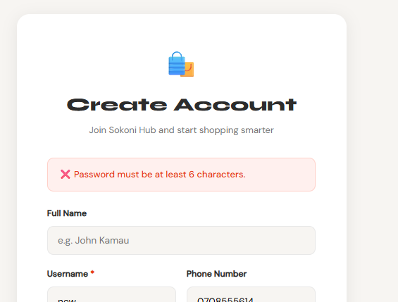

Fig 3.1.3: PHP Syntax Practice
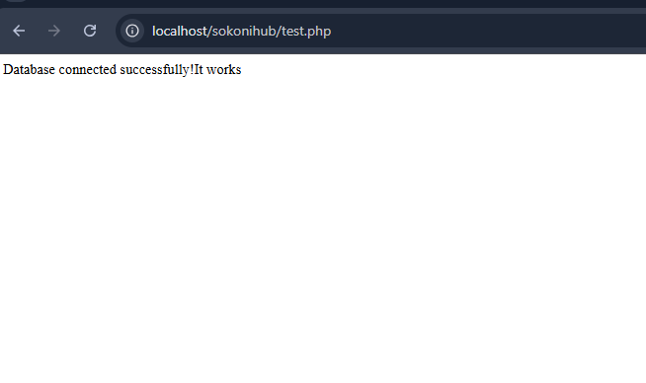

Fig 3.1.4: Database Connection Script
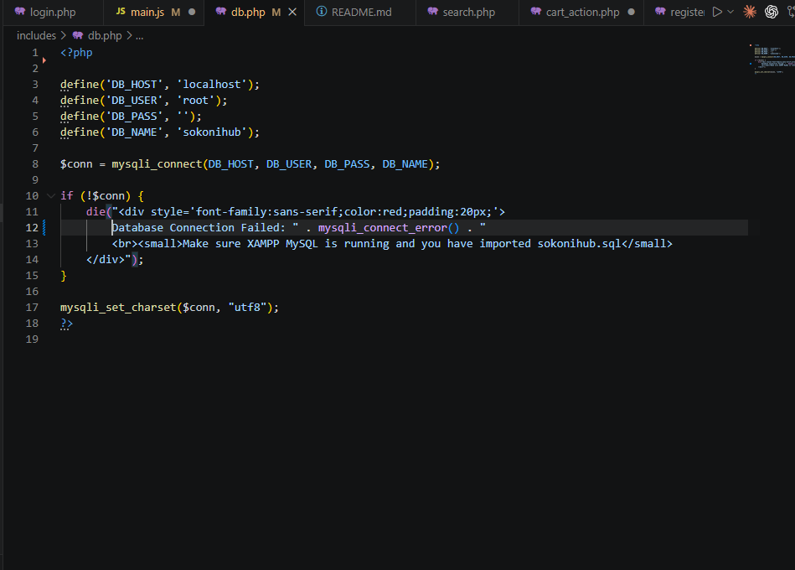

Fig 3.1.5: Dynamic User Input Handling
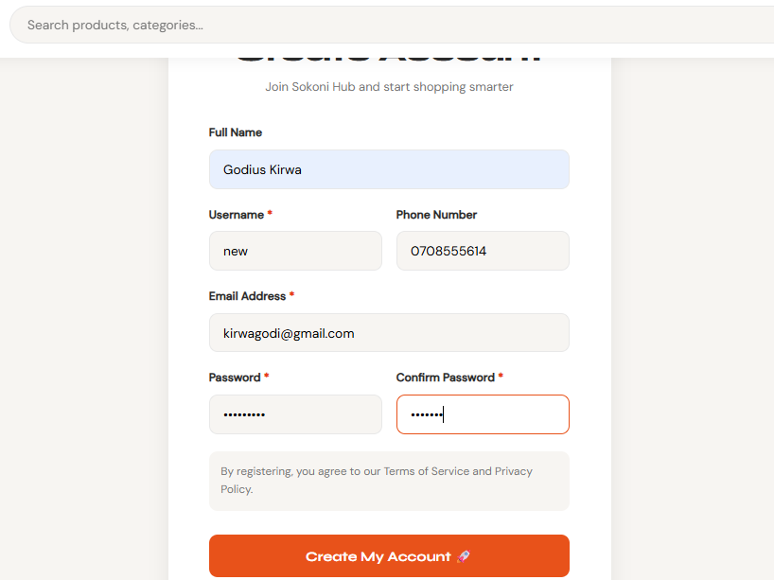

3.2 Week 3 Reflection
This week involved learning and implementing JavaScript and PHP fundamentals required for building interactive web applications.
JavaScript was used for form validation and improving user experience by preventing invalid submissions. PHP was used to process user inputs and communicate with the MySQL database.
I also practiced writing database connection scripts and handling dynamic form data. One challenge was understanding how frontend validation complements backend processing, which became clearer through practical implementation.
The screenshots demonstrate form validation, password checking, PHP coding exercises, database connectivity, and dynamic user input processing.

Week 4 Database creation

Fig 4.1: Database Created in phpMyAdmin
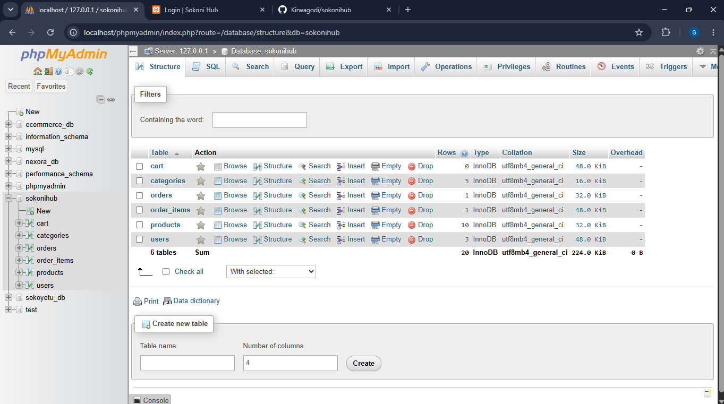

Fig 4.2: Users Table Structure
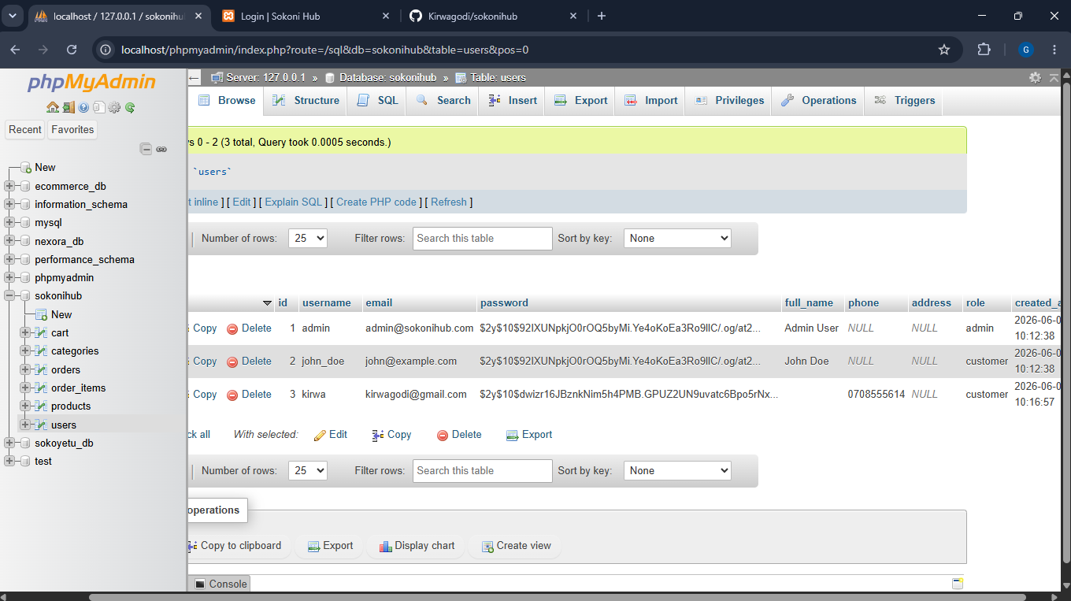

Fig 4.3: Products Table Structure
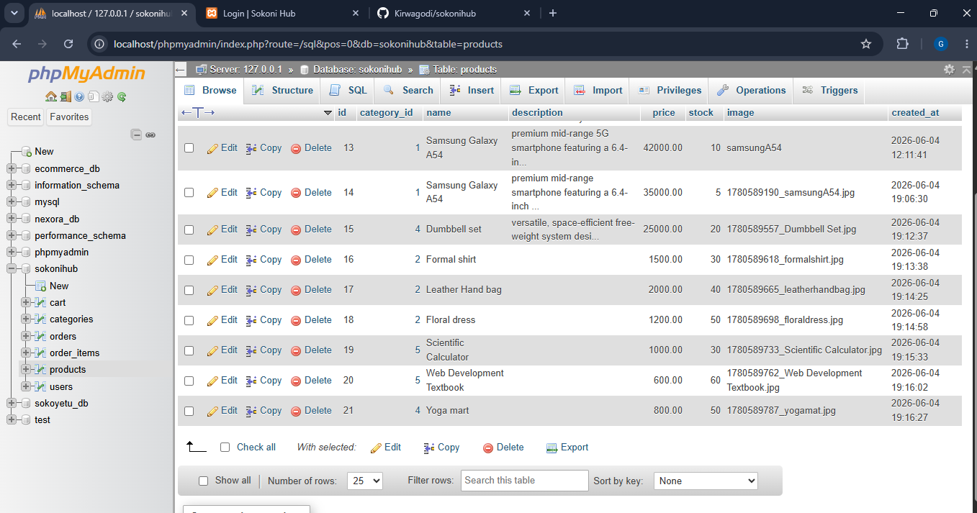

Fig 4.4: Database Relationships
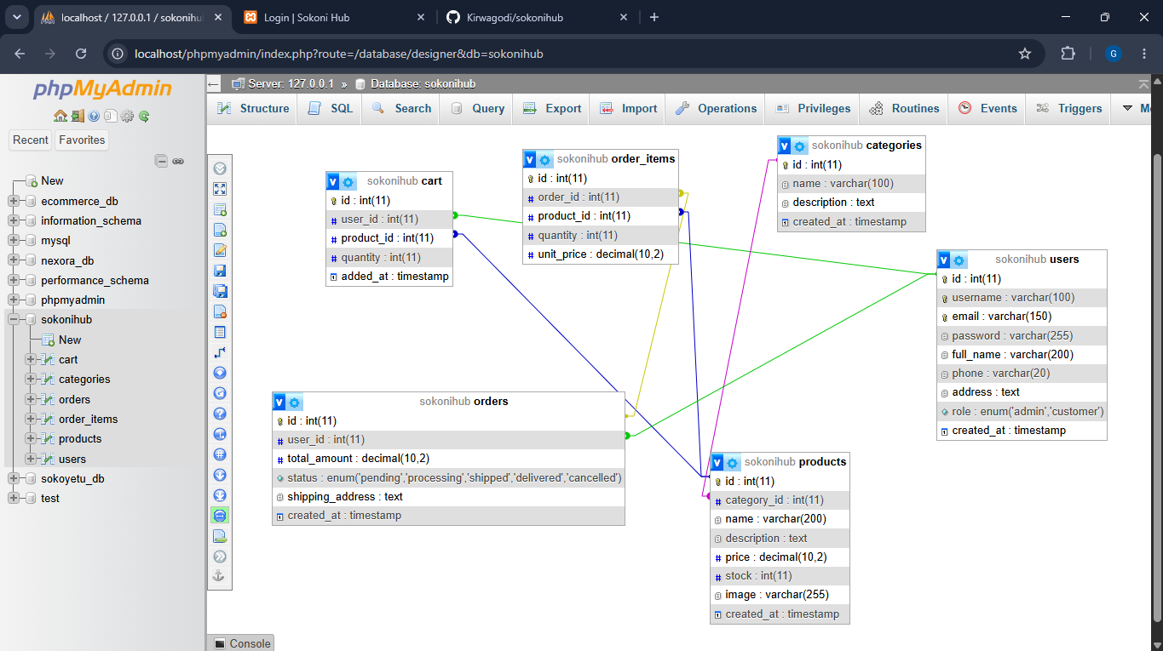

Fig 4.5: Sample Records in Database
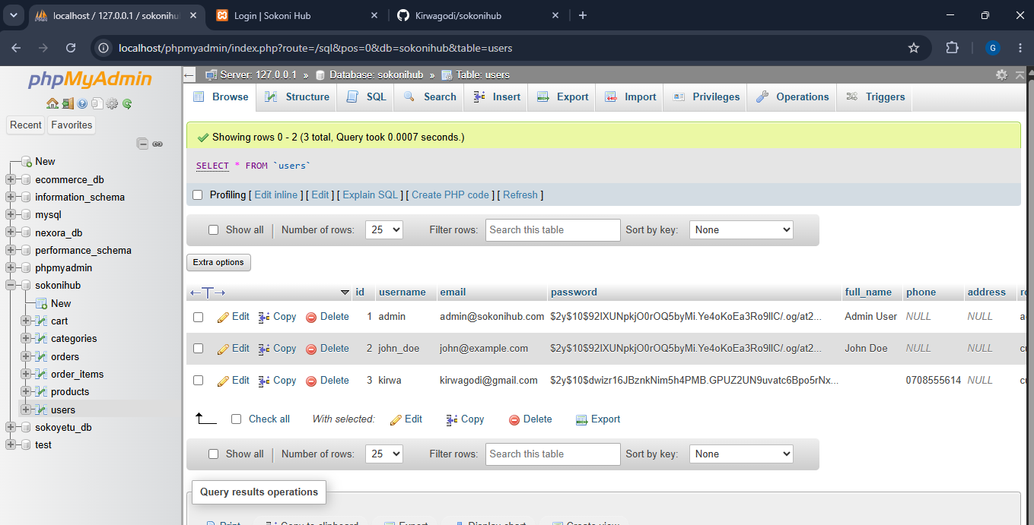

4.2 Week 4 Reflection
This week focused on designing and creating the SokoniHub database using MySQL and phpMyAdmin.
Tables such as users, products, orders, and cart were created with appropriate relationships. Database normalization techniques were applied to reduce data redundancy and improve efficiency.
A challenge encountered was establishing correct foreign key relationships between tables, which was resolved through careful planning and testing.
The screenshots demonstrate database creation, table structures, relationships, sample records, and successful database implementation. This stage provided a structured foundation for storing and managing system data.

Week 5: User Registration and Login Module

Fig5.1: Registration Form
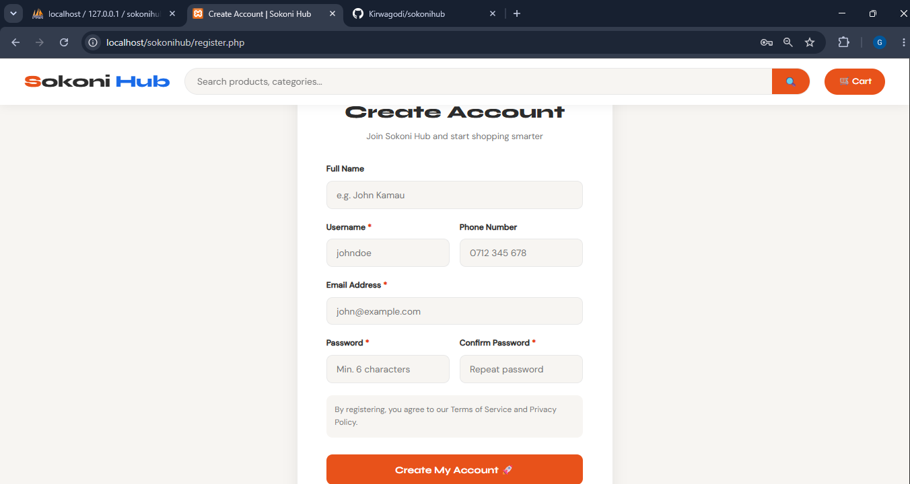

Fig 5.2: Login Form
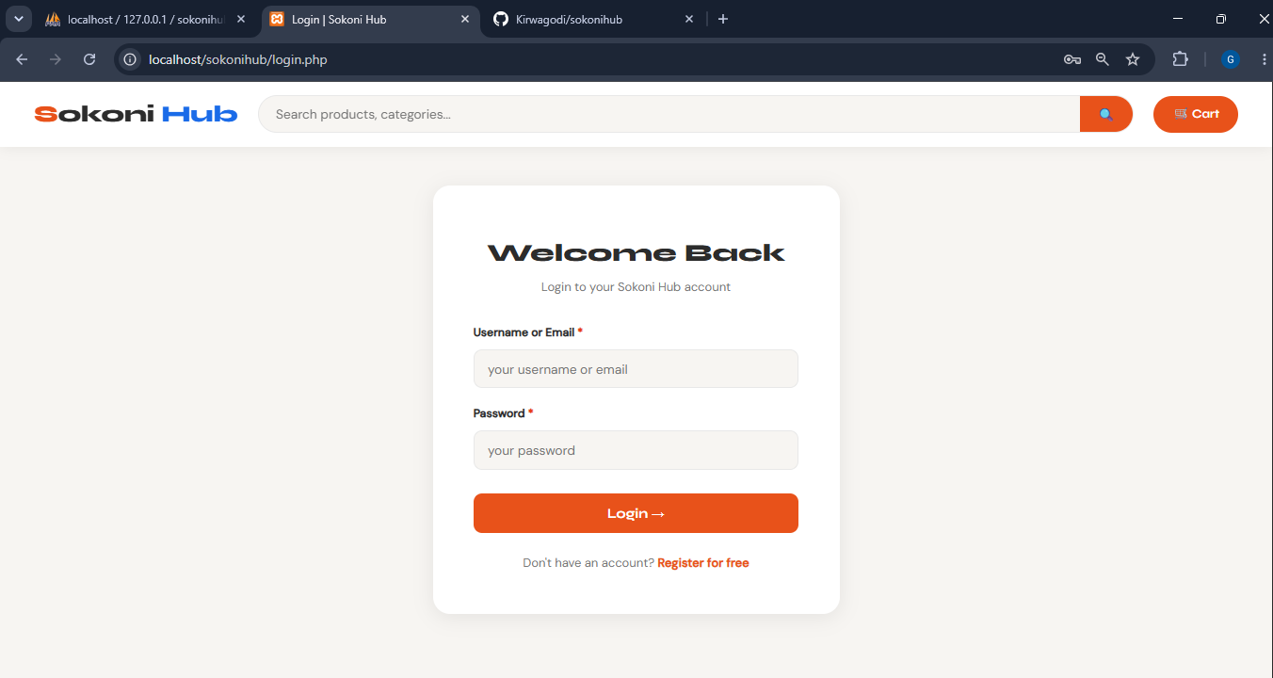

Fig 5.3: User Data Stored in Database
Fig 5.4: Successful Login


Fig 5.5: Password Hashing.
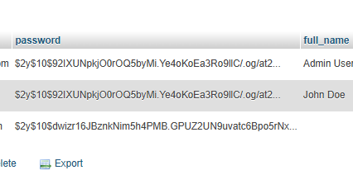

5.2 Week5 Reflection
This week involved developing the user authentication module. Registration and login forms were created using HTML, CSS, PHP, and MySQL.
Password hashing was implemented to improve security before storing user credentials in the database.
Validation checks were added to prevent duplicate accounts and invalid inputs. One challenge was managing user sessions after successful login, which was resolved using PHP session management.
The screenshots demonstrate user registration, login functionality, database storage, session creation, and successful authentication processes within the system.

